



May, 2026 Vol.6(5), 1525-1529

Popular Article

Lactational Disorders in Cattle

M. Rajashri^{*1}, K.Yashaswini²
^{*1}Assistant professor, ²Contract Teaching Faculty,
Department of Veterinary Gynaecology and Obstetrics, College of Veterinary science,
P.V.Narsimha Rao Telangana Veterinary University, Mamnoor, Warangal-506166
*Corresponding Author Email: rsri0835@gmail.com

Lactational disorders are abnormalities associated with milk synthesis, secretion, milk ejection, or mammary gland health occurring during the postpartum period. These disorders are economically important in dairy cattle because they affect:
- Milk production
- Calf growth
- Passive immunity
- Fertility and reproductive efficiency
The major lactational disorders in cattle include:
- Mastitis
- Agalactia
- Dysgalactia / Hypogalactia
- Udder edema
- Galactostasis (milk retention)
CLASSIFICATION OF LACTATIONAL DISORDERS
- Functional Disorders – Agalactia, Hypogalactia, Dysgalactia, Failure of milk let-down
- Infectious Disorders - Mastitis
- Metabolic & Nutritional Disorders - Udder edema, Milk fever-associated lactational failure
1. MASTITIS - Inflammation of the mammary gland characterized by physical, chemical, and bacteriological changes in milk and pathological changes in glandular tissue.
Mastitis
Etiology - Infectious Agents: Common pathogens include:Staphylococcus aureus,
Streptococcus agalactiae, Escherichia coli, Klebsiella spp.
Predisposing Factors
Environmental - Dirty housing, Wet bedding, Poor sanitation
Managemental - Improper milking techniques, Faulty milking machines, Teat injuries
Physiological - Transition-period immunosuppression increases susceptibility to mastitis. The uploaded text explains that stress and metabolic demands around calving impair neutrophil and lymphocyte function. Vitamin E and selenium deficiencies are associated with increased mastitis incidence.
Classification
Based on Clinical Severity
  - Clinical Mastitis- Visible abnormalities in udder and milk.
  - Subclinical Mastitis - No obvious signs but elevated somatic cell count.
  - Peracute Mastitis- Severe toxemia and systemic illness.
  - Chronic Mastitis- Long-standing fibrosis and reduced milk production.
Pathogenesis of Mastitis
Bacterial entry through teat canal
↓
Colonization of mammary tissue
↓
Inflammatory mediator release
↓
Vascular permeability increases
↓
Milk composition changes
↓
Reduced milk yield and gland damage
Clinical Signs- Swollen hot painful udder, Clots/flakes in milk, Reduced milk yield, Fever, Depression, Anorexia. Severe toxic mastitis may lead to shock.
Diagnosis
Field Tests - California Mastitis Test (CMT)
Laboratory Tests- Somatic Cell Count (SCC), Bacterial culture, Milk pH and chloride changes
Treatment
Medical Therapy
- Intramammary antibiotics, systemic antibiotics, NSAIDs, Fluid therapy
Supportive Measures
- Frequent stripping, Warm fomentation
Prevention
- Hygienic milking
- Post-milking teat dipping
- Dry cow therapy
- Proper bedding management
- Adequate nutrition
2. AGALACTIA
Definition - Complete absence of milk secretion after parturition.
Etiology:
Nutritional Causes: Energy deficiency, Protein deficiency, Dehydration
Hormonal Causes- Failure of prolactin secretion, Failure of oxytocin release
Disease Conditions: Severe mastitis, Metritis, Septicemia
Stress Factors -Stress inhibits oxytocin-mediated milk let-down.
Clinical Signs: Empty udder, Hungry calf, Continuous calf vocalization, Poor neonatal growth
Diagnosis: is based on History, Udder examination, Milk secretion assessment.
Treatment: Improve nutrition, Oxytocin therapy, Treat underlying disease, Frequent suckling stimulation
3. DYSGALACTIA / HYPOGALACTIA
Definition: Partial impairment or reduction in milk secretion. Unlike agalactia, some milk is produced.
Causes – Stress, Poor nutrition, Chronic disease, Mastitis, Metabolic disorders
Clinical Signs- Reduced milk flow, Incomplete udder emptying, Poor calf growth
Pathogenesis
Stress/pain
↓
Reduced oxytocin release
↓
Failure of milk let-down
↓
Milk retention
↓
Reduced lactation
Treatment
- Improve feeding, Stress reduction, Oxytocin, Correct primary disease
4. GALACTOSTASIS (MILK RETENTION)
Definition: Retention of milk due to incomplete evacuation.
Causes - Infrequent milking, Painful udder, Teat obstruction
Clinical Signs- Enlarged tense udder, Pain, Predisposition to mastitis
Treatment- Frequent milking, Oxytocin, Warm compress
5. UDDER EDEMA - Udder edema is one of the most common periparturient mammary disorders in dairy cattle, especially in high-yielding heifers and cows near calving. It is characterized by excessive accumulation of serous fluid in the interstitial tissues of the udder and adjacent ventral abdominal wall.
Synonyms - Mammary edema, Postparturient udder edema
Usually develops: 1–2 weeks before parturition and peaks immediately after calving
Etiology- Udder edema is multifactorial.
1. Increased Hydrostatic Pressure
During late pregnancy:
- Mammary blood flow increases markedly
- Venous pressure rises
- Fluid leaks into interstitial tissues
2. Reduced Venous Return
Compression of veins by:
- Enlarged uterus
- Enlarged mammary gland
3. Lymphatic Obstruction
Impaired lymphatic drainage causes:
- Retention of tissue fluid
- Distension of mammary tissue
4. Nutritional Factors: High sodium intake, Excess salt causes fluid retention., Excess concentrate feeding may predispose to edema., Potassium-rich diets - Can aggravate fluid accumulation.
5. Hormonal Factors: Estrogen increases: Vascular permeability, Sodium and water retention. This contributes to edema formation during late gestation.
6. Lack of Exercise: Reduced movement: Decreases venous return, Predisposes to edema
Clinical Signs- Pitting edema, Enlarged udder, Difficulty walking
Treatment- Exercise, Massage, Diuretics, Salt restriction
Pathogenesis
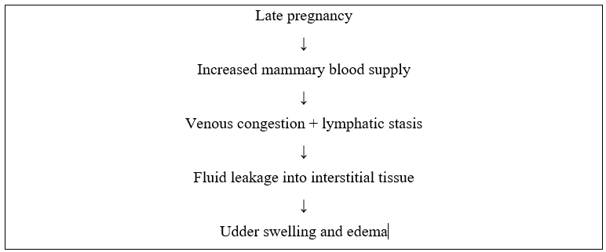
Clinical Signs
Mild Cases - Slight enlargement of udder, soft swelling, non-painful
Severe Cases - Massive pendulous udder, tense shiny skin, difficulty walking, pitting edema
- Swelling extends to Teats, Ventral abdomen, Perineal region
Diagnosis - Based on: Clinical examination, History of recent calving and pitting nature of swelling - Pitting Edema - When finger pressure is applied: An indentation remains temporarily
Treatment
1. Mild Cases: Usually self-limiting.
Management includes: Frequent milking, Exercise, Salt restriction
2. Severe Cases- Diuretics: Example: Inj. Furosemide - Helps remove excess fluid.
Udder Massage - Gentle massage improves venous drainage, lymphatic circulation
Supportive Bandages - Udder supports reduce pendulous strain, trauma
Cold or Warm Compress - May improve circulation and comfort.
3. Dietary Management: Reduce: Sodium intake, Excess concentrates, provide balanced ration, adequate roughage

